**What is WebRTC?**

WebRTC (Web Real-Time Communication) is an API definition that enables Web applications and sites to capture and optionally stream audio and/or video media, as well as to exchange arbitrary data between browsers without requiring an intermediary, it is also use in P2P file sharing without the need of either internal or external plugins.

**Who own WebRTC?**

In May 2010, Google bought Global IP Solutions or GIPS, a VoIP and videoconferencing software company that had developed many components required for RTC, such as codecs and echo cancellation techniques. ... In May 2011, Google released an open-source project for browser-based real-time communication known as WebRTC.

**Who use WebRTC?**

1. Google Meet and Google Hangouts

Google Meet (or more accurately, Hangouts) is most probably one of the main reasons we have WebRTC.

1. Facebook

* Messenger – video chat and group video chat, mobile and browser
* Facebook Live – when co-broadcasting
* VR Chat – video calls in Oculus
* Then there’s Workplace by Facebook and Instagram Live Video Chat

1. Discord
2. Amazon Crime

**Advantages Of WebRTC**

1. It's free

* WebRTC is an open-source application programming interface (API)

1. Platform and device independence

* Any WebRTC-enabled browser with any operating system and a web services application can direct the browser to create a real-time voice or video connection to another WebRTC device or to a WebRTC media server.

1. Secure voice and video

* The Secure RTP protocol (SRTP) is used for encryption and authentication of both voice and video. This is especially beneficial over WiFi networks.

1. Advanced voice and video quality

* WebRTC uses the Opus audio codec that produces high fidelity voice.

1. Reliable session establishment

* The reliable operation avoids server-relayed media and thereby reduces latency and increases quality. It also reduces the server load.

1. Multiple media streams

* WebRTC is an adaptive network solution that compensates and adjusts to changing network conditions. It adjusts the communications quality, responds to bandwidth availability, detecting and avoiding congestion.

1. Adaptive to network conditions

* The APIs and signaling can negotiate the size and format for each endpoint individually.

1. Interoperability with VoIP and video

* The biggest value of WebRTC is its promise of interoperability with existing voice and video systems. This includes devices using SIP, Jingle, XMPP, and the PSTN.

1. Rapid application development

* Developers will experience a streamlined development process reducing the time for application implementation. Detailed knowledge of WebRTC will not be necessary because of the standardized APIs. Finally, the voice and video codecs are license-free.

**For those businesses that work from home**

Nowadays, after the lockdowns that have been happening during last year, it is common to find situations in which teleworking coexists with face-to-face work. Either because some of the employees have been forced to carry out their activity outside the office or because companies offer this possibility, remote working is already a reality.

In this sense, communication, both external and internal, is a fundamental aspect. In fact, employees who are teleworking must be able to communicate effectively with customers and the rest of the team, as if they were in the office, and the company must be concerned to ensure this aspect.

In these cases, works with WebRTC is the ideal option. Unlike those that work with SIP, they can be used anywhere if you have an Internet connection. As it is an open source protocol, you don’t need to download any additional software or install any additional equipment. Simply by accessing the browser of our computer, mobile or tablet.

Nowadays, at least one of these devices is within everyone’s reach. This facilitates teleworking, in addition to reducing costs for the company, since it will not have to make any additional investment to adapt the employee’s environment.

On the other hand, all employees can talk to each other through voice, video and chat, no matter where they are working from.

**The Different between WebRTC and WEBSocket**

Let’s start with WebSocket, WebSocket is a computer communication protocol that enables communication and data exchange. With the help of this web communication solution and WebRTC technology combined, modern web applications allow you to exchange audio and video content with a large number of users in real time.

**WHAT IS A WEBSOCKET?**

* Technology for opening communication between browser and server;
* Send messages to web server asynchronously;
* Receive event-drive responses without polling for a reply;
* Full-duplex connection stream between client and server;
* Dedicated communication protocol named «ws»;
* Callback functions for handling events of incoming messages;
* JSON often used as container for exchanging messages and data.

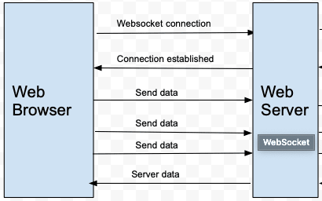

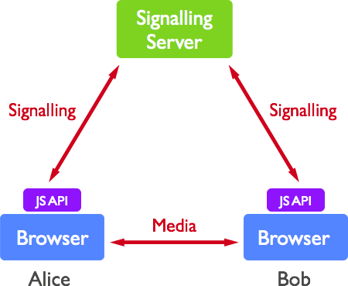

* Two of the pictures showing the difference between WebSocket and WebRTC.